Kinematics Analysis Operators

Began looking at a subset of the data including the operators that have lead and rampart cases. I was going to assess the same kinematics values data as before. Looking at the averages of the data primarily.

# Average Maximum Degrees

* 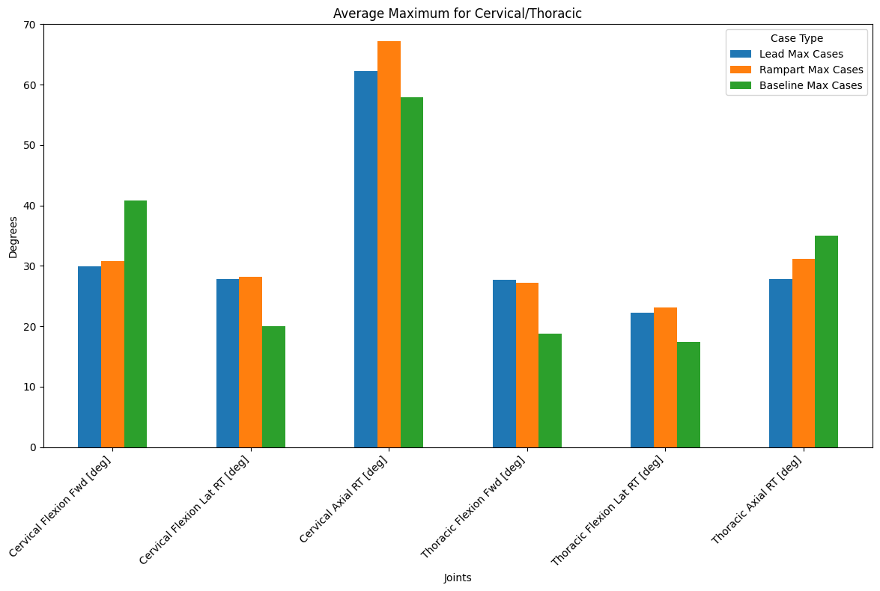
* 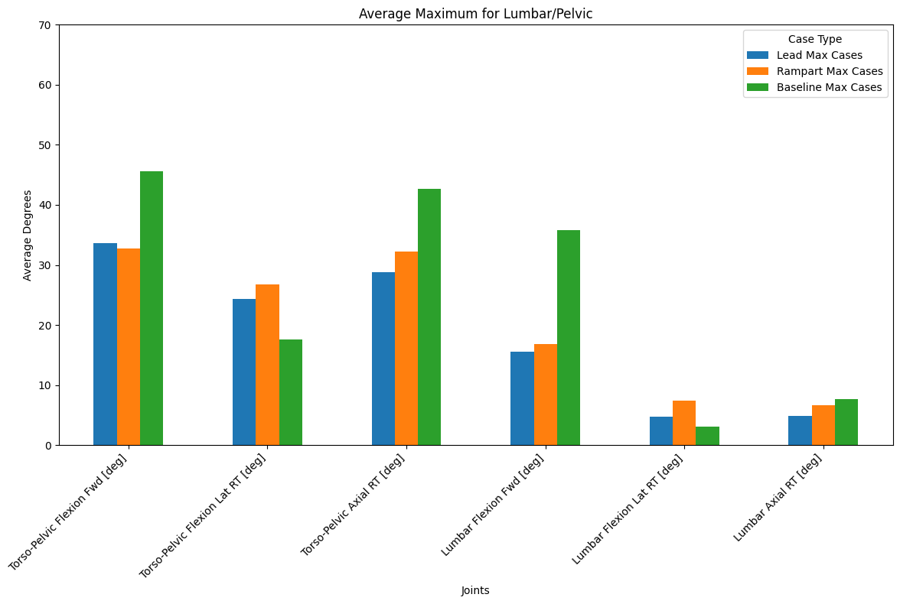

# Average Minimum Degrees

* 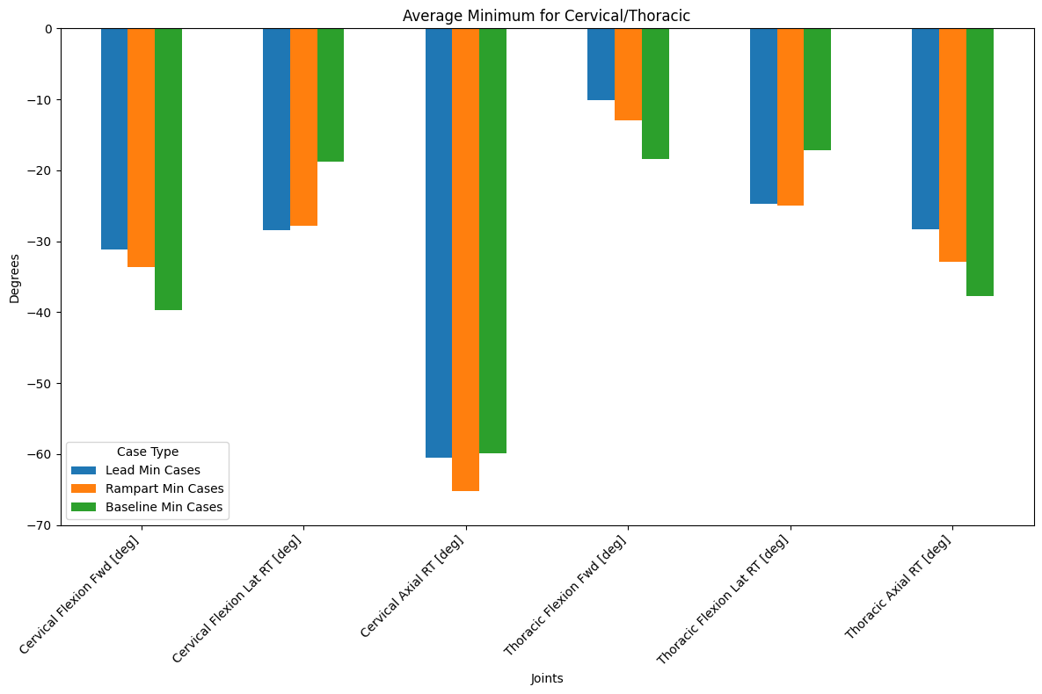
* 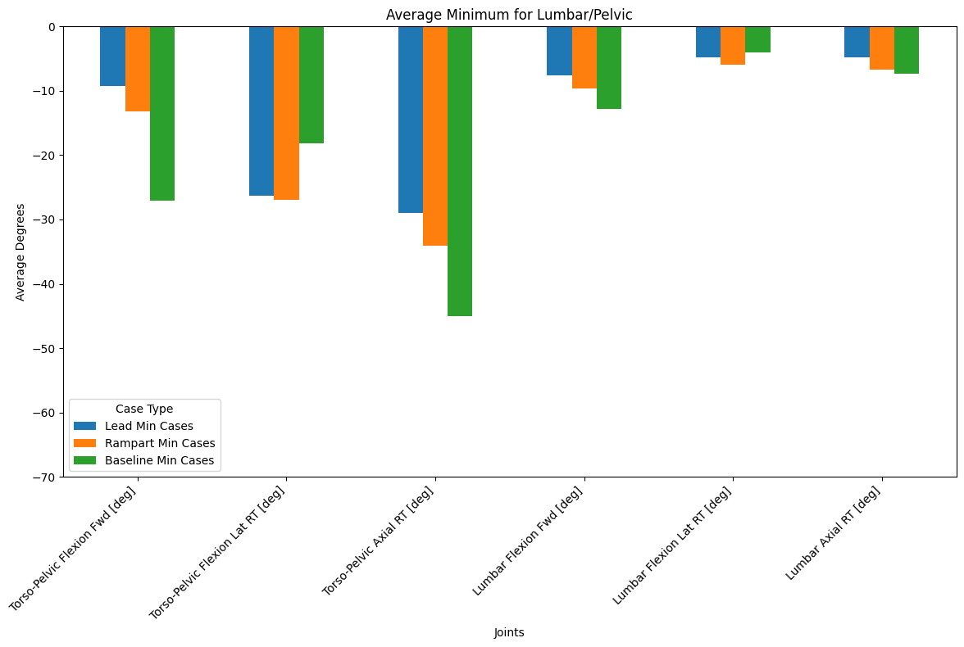

# Average Range Degrees

* 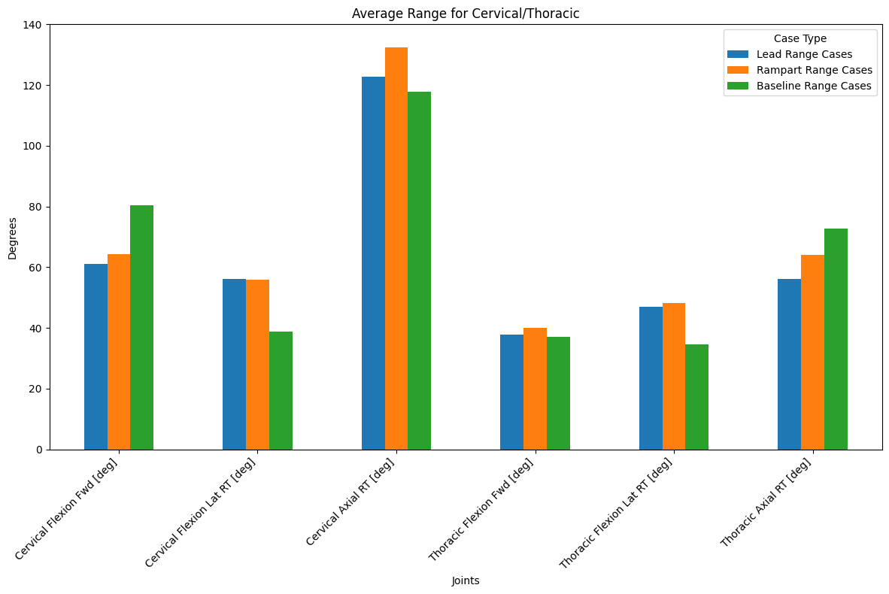
* 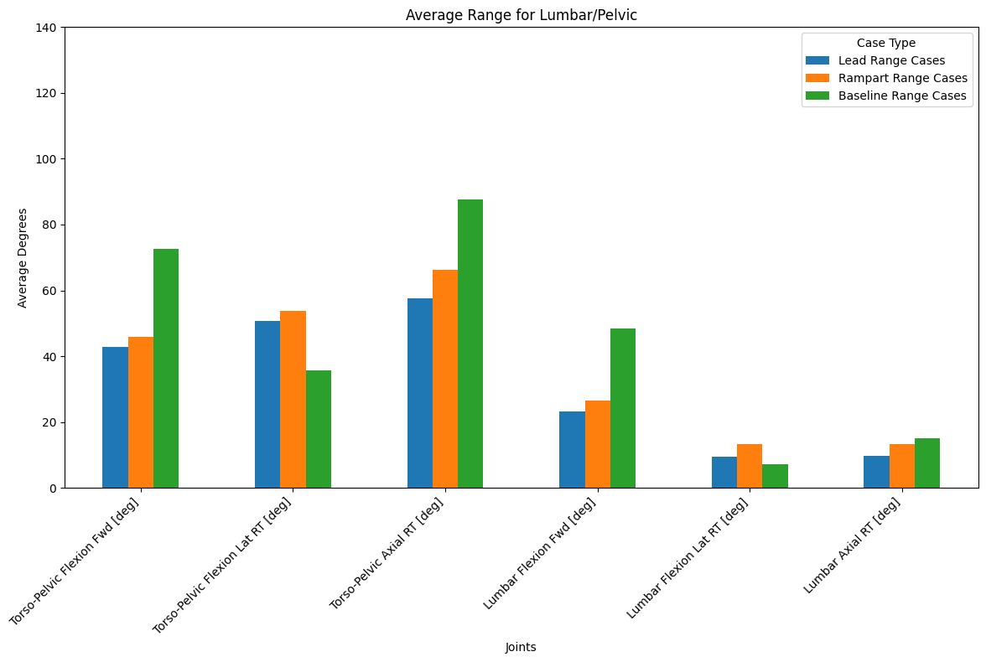

# 20 Degrees Threshold

* 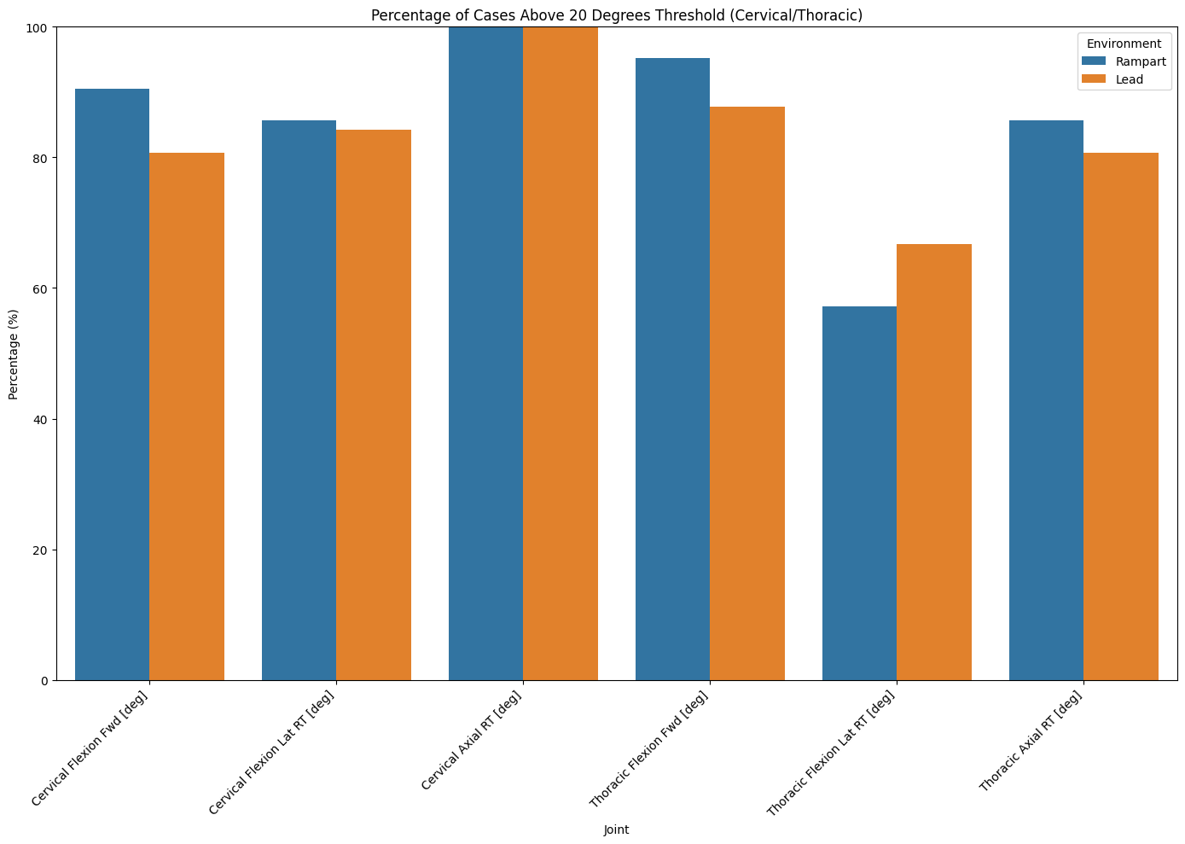
* 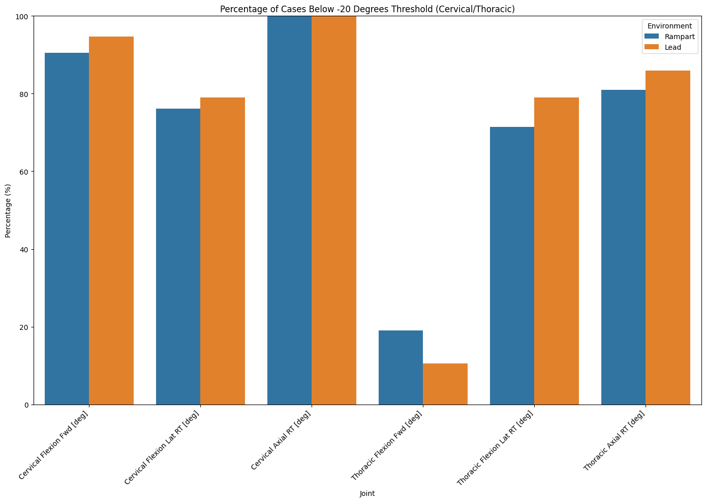
* 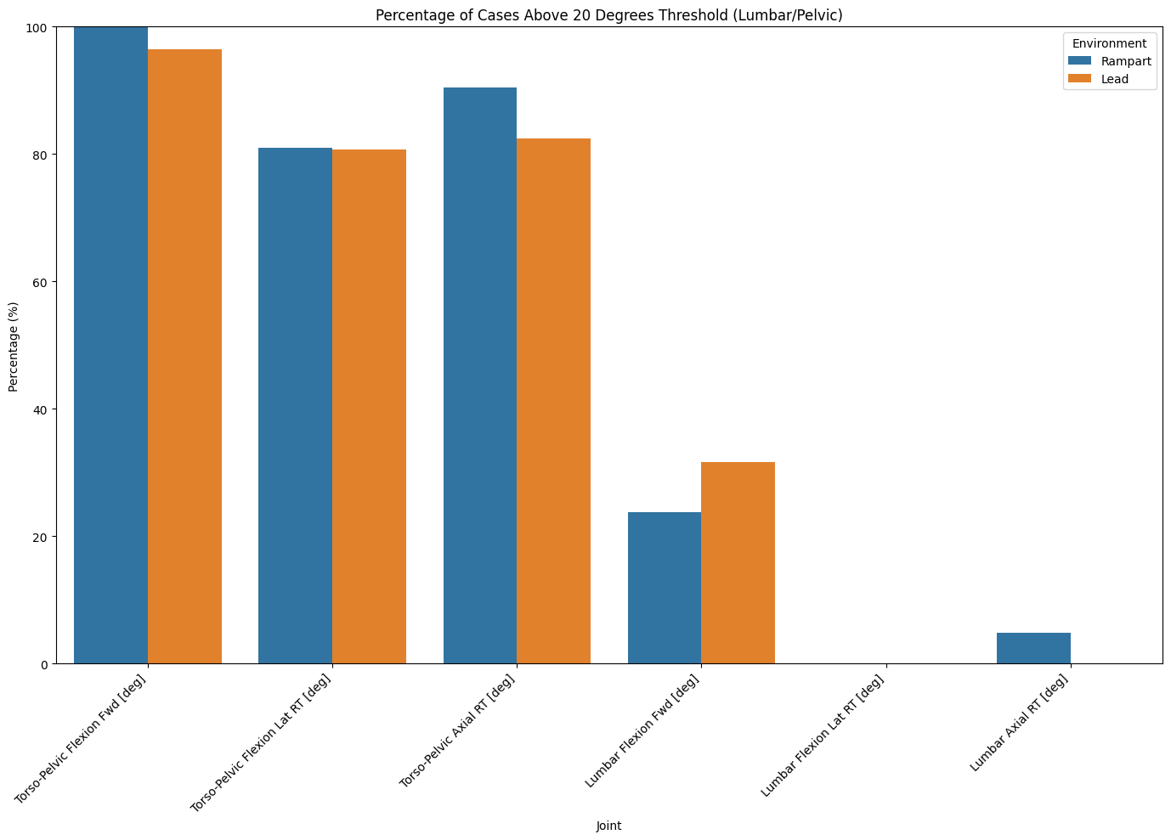
* 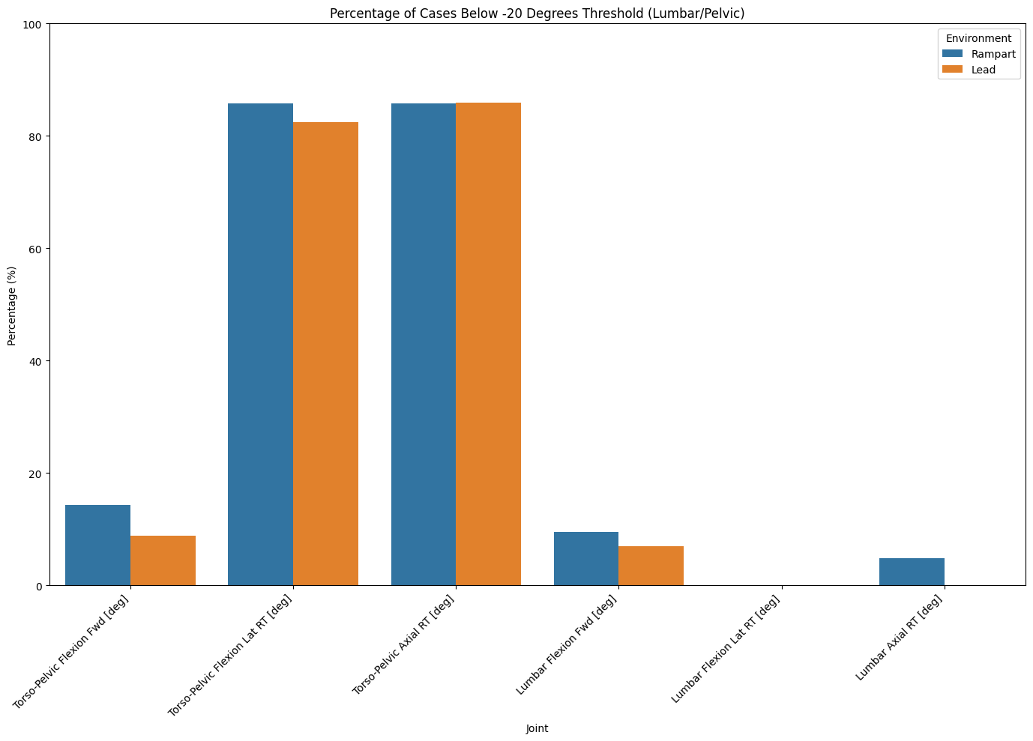

# 60 Degree Threshold

* 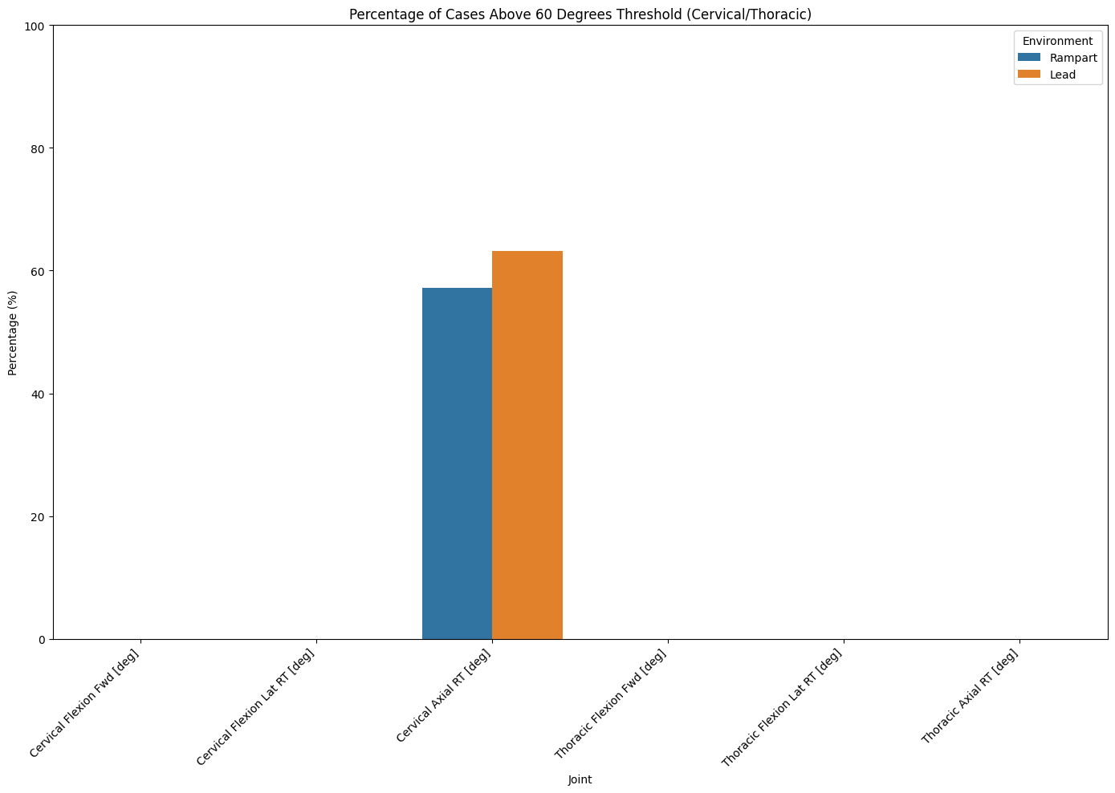
* 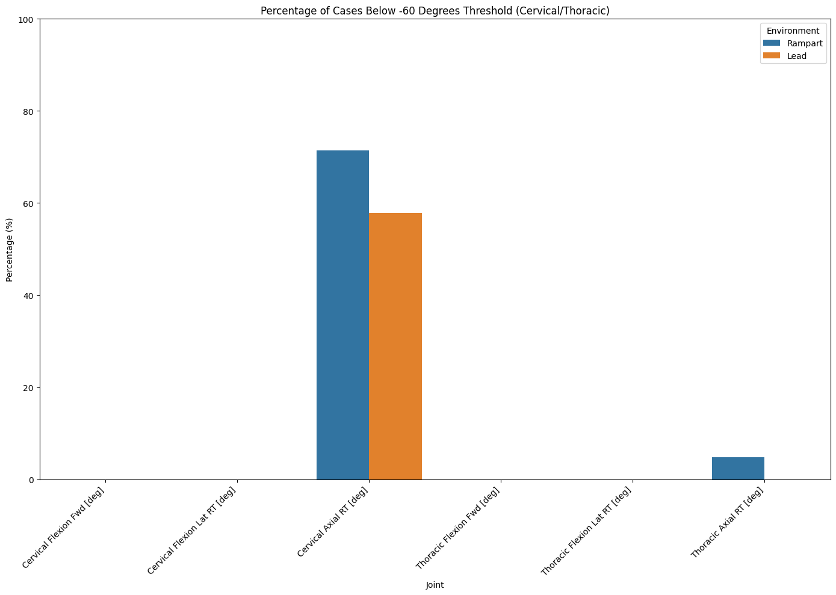
* 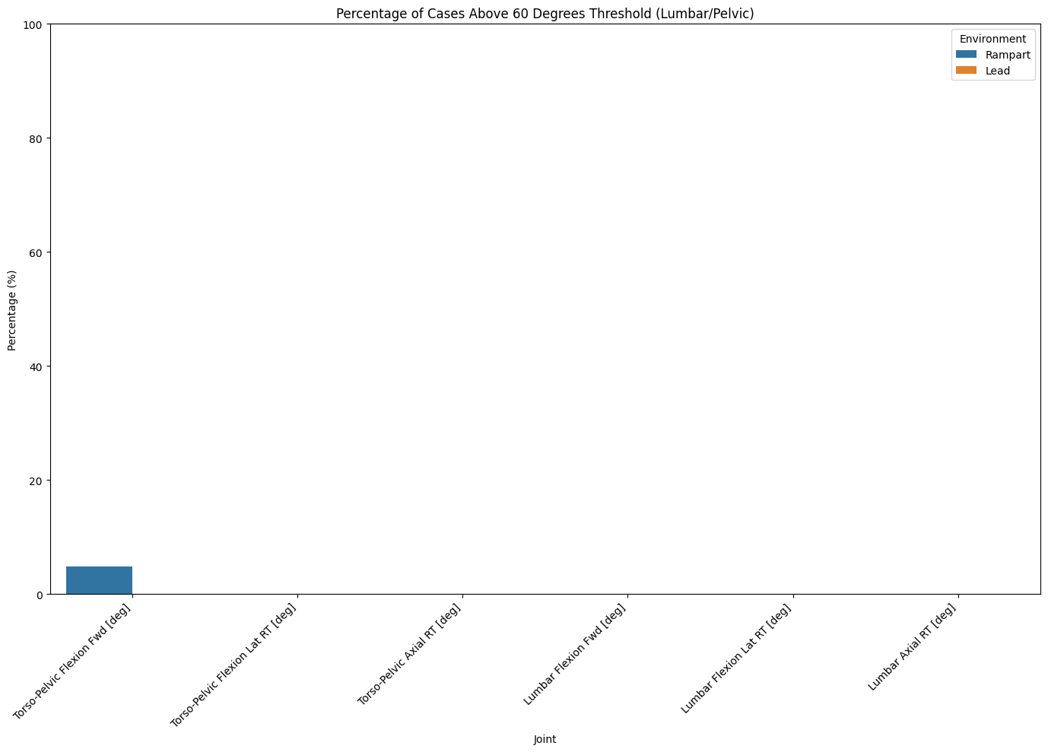
* 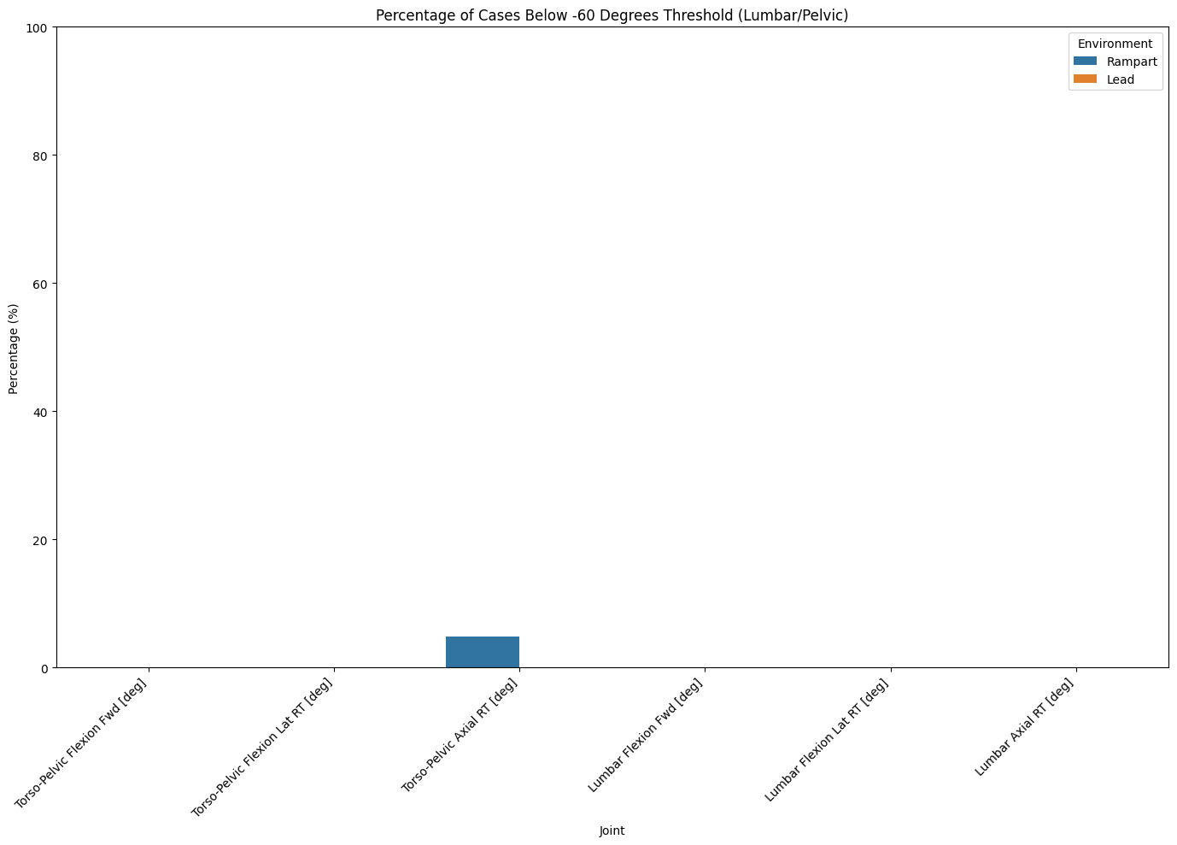

# Conclusion

* Subjects in most cases went into moderate-high risk thresholds of degrees. We don’t know how long that is from the kinematics data, but we at least know that they experienced that at some point. The duration of those cases will be more important and can be seen in the joint angles analysis.
* Generally, subjects in most cases didn’t experience degrees greater than 60 of normal position. That is good and expected given that the activity is not too strenuous or stretching the joints.